**PRESS RELEASE**

**Public Procurement Commission (PPC) Engages with Inter-American Development Bank (IDB) to Strengthen Procurement Processes**

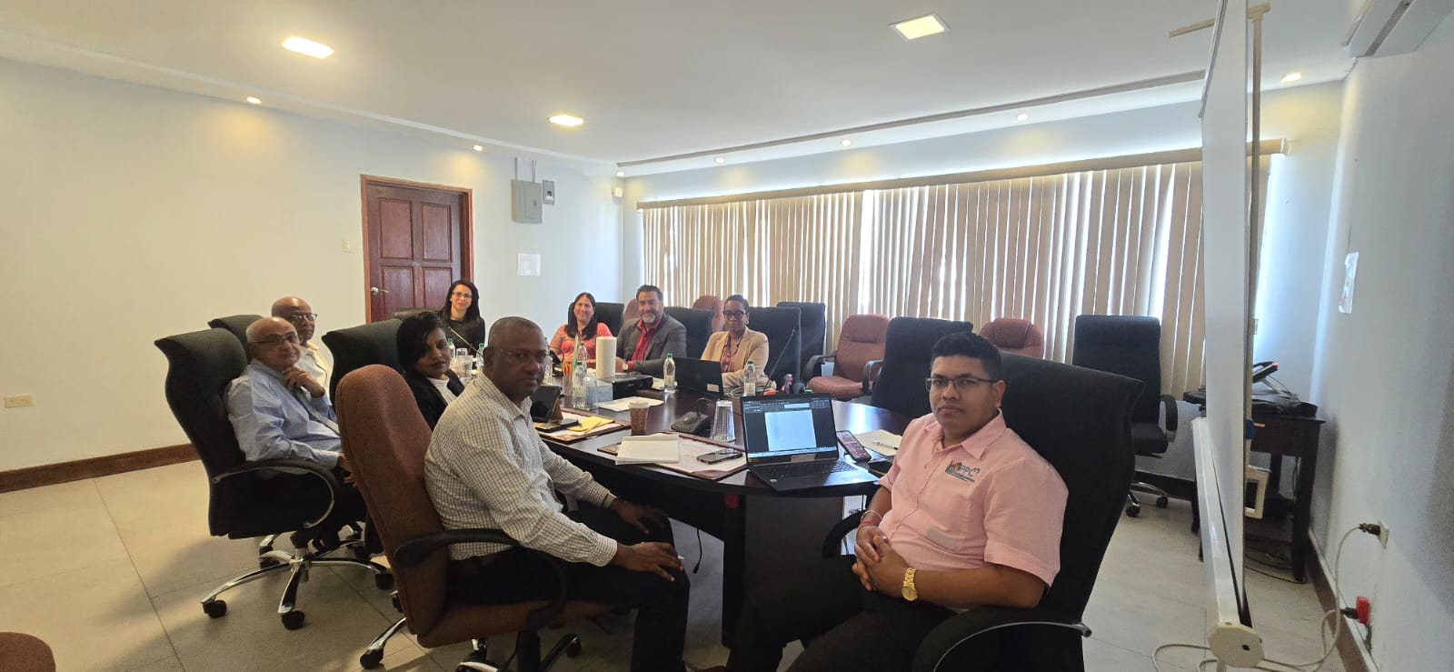

*8Th May 2024, Georgetown, Guyana.* The Public Procurement Commission (PPC) held a meeting with representatives from the Inter-American Development Bank (IDB) on May 8th, 2024, at the PPC’s offices located at 262 New Garden Street, Queenstown. The meeting was aimed at enhancing the execution of the commission’s functions towards strengthening procurement processes in Guyana and was attended by key officials from both organizations.

The PPC was represented by Ms. Pauline Chase, Chairman; Mr. Berkley Wickham, Deputy Chairman; and Commissioners Dianna Rajcumar, Joel Bhagwandin, and Rajnarine Singh along with its Chief Executive Officer, Mr. Michael Singh. Representatives from the IDB included Ms. Lorena Solórzano Salazar, IDB Representative in Guyana; Mr. Iván-Alonzo Gaviria, Chief of Operations; and Ms. Patricia Yamilee Payen, Procurement Specialist.

Under the mandate of Articles 212W and 212AA of the Constitution of the Co-operative Republic of Guyana, the PPC is vested with oversight of the public procurement system and as enabled by Section 17(2) of the Procurement Act, Cap. 73:05 is *inter alia* responsible for organizing training seminars on procurement and making recommendations to the subject Minister for amendment(s) to the legislation to enhance the efficiency of the procurement process.

During the meeting, several key matters were addressed, including:

* **Assistance from the IDB:** The IDB pledged its support in guiding the PPC in international best practices in developing Standard Operating Procedures (SOPs) for monitoring the procurement process, execution of contracts oversight, and standard bidding documents. This includes international best practices in the evaluation process, ~~along with an~~ evaluation guide and standard evaluation report format.
* **Collaboration for Evaluator Training:** The IDB committed to collaborating with the PPC in training evaluators in international best practices for the evaluation process. This builds on previous training exercises of the PPC supported by the IDB.

The meeting follows prior engagements between the PPC and the IDB particularly in the area of legislative reform aimed at improving Guyana's public procurement framework emanating from the 2018 Report, *"Strengthening of the Public Procurement Framework in Guyana,"* prepared by Ms. Sabine Engelhardt, IDB Consultant, Attorney-at-Law, and Procurement Specialist.

In the past, the IDB has engaged with the Public Procurement Commission on various initiatives, and other areas of support, including training for contractors and suppliers in IBD funded projects.

The PPC maintains an ongoing working relationship with the IDB to continually strengthen public procurement systems. This meeting is part of the PPC's commitment to fostering collaboration and implementation of best practices to optimize procurement procedures for the benefit of the nation.

For further information, please contact the Public Procurement Commission at (592) 226-3729, (592) 231-7306, and (592) 226-2364, or via email at publicprocurement@ppc.org.gy.

**Contact:**

**Public Procurement Commission  
262 New Garden Street, Queenstown, Guyana  
Phone: (592) 226-3729, (592) 231-7306, (592) 226-2364  
Email: publicprocurement@ppc.org.gy  
Website:** [**www.ppc.org.gy**](https://chatgpt.com/c/www.ppc.org.gy)

--- THE END ---